SQL TABLE STATUS

🎯 Purpose
# Source: AI Source: Provided by: [Data Path: Persons Table -> ID Column: 1, Name_En Column: Motasem Essam] -> From: [ChatGPT] on [6/11/2026]
SHOW TABLE STATUS provides metadata about tables in the current database — such as engine type, row count, size on disk, creation time, and more. It's useful for performance tuning, debugging, and maintenance.

✅ Syntax
# Source: AI Source: Provided by: [Data Path: Persons Table -> ID Column: 1, Name_En Column: Motasem Essam] -> From: [ChatGPT] on [6/11/2026]
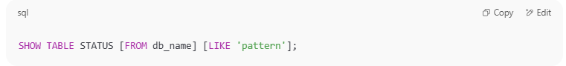
SHOW TABLE STATUS [FROM db_name] [LIKE 'pattern'];

- FROM db_name: Optional — specify a database.
- LIKE 'pattern': Optional — filter by table name.

🔍 Example
# Source: AI Source: Provided by: [Data Path: Persons Table -> ID Column: 1, Name_En Column: Motasem Essam] -> From: [ChatGPT] on [6/11/2026]
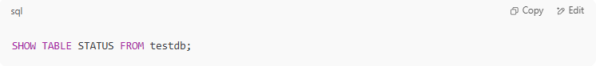
SHOW TABLE STATUS FROM testdb;

or simply:
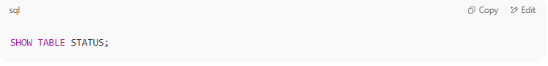
SHOW TABLE STATUS;

Sample Output:
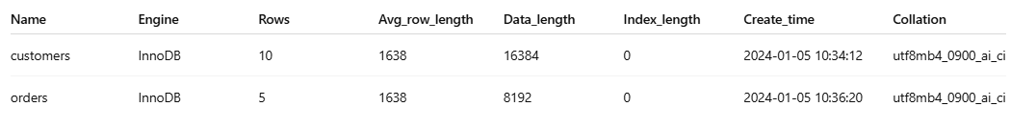
Name | Engine | Rows | Avg_row_length | Data_length | Index_length | Create_time | Collation
customers | InnoDB | 10 | 1638 | 16384 | 0 | 2024-01-05 10:34:12 | utf8mb4_0900_ai_ci
orders | InnoDB | 5 | 1638 | 8192 | 0 | 2024-01-05 10:36:20 | utf8mb4_0900_ai_ci

🧠 Useful Columns
# Source: AI Source: Provided by: [Data Path: Persons Table -> ID Column: 1, Name_En Column: Motasem Essam] -> From: [ChatGPT] on [6/11/2026]
- Name – table name
- Engine – storage engine (e.g. InnoDB, MyISAM)
- Rows – estimated number of rows
- Data_length – size of the data in bytes
- Index_length – size of indexes in bytes
- Create_time – when the table was created
- Collation – character set collation

🧪 Practice
# Source: AI Source: Provided by: [Data Path: Persons Table -> ID Column: 1, Name_En Column: Motasem Essam] -> From: [ChatGPT] on [6/11/2026]
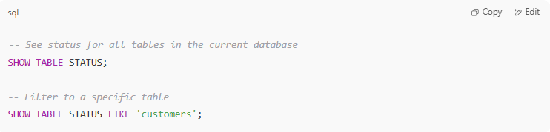
-- See status for all tables in the current database
SHOW TABLE STATUS;

-- Filter to a specific table
SHOW TABLE STATUS LIKE 'customers';

🚀 Tips
# Source: AI Source: Provided by: [Data Path: Persons Table -> ID Column: 1, Name_En Column: Motasem Essam] -> From: [ChatGPT] on [6/11/2026]
- Helps to monitor table size and row counts.
- Useful when optimizing query performance or estimating backup sizes.
- Combine with SHOW CREATE TABLE for full table insight.

Would you like the next lesson on:
🔸 SHOW INDEX or
🔸 DESCRIBE / EXPLAIN?

Example

prepared commands
# Source: ScreenShot Source: Provided by: [Persons Table -> ID Column: 1, Name_En Column: Motasem Essam] -> Tool: [Automation Table -> ID Column: 16, Name_En Column: Screen Capture] -> From [Operating System: Wampserver64 -> phpmyadmin] on [6/11/2026]
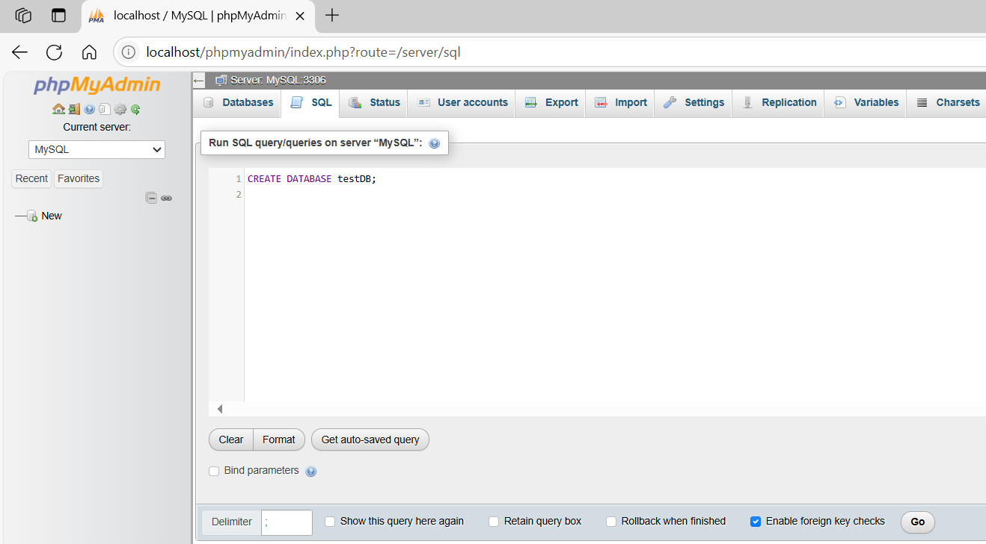
CREATE DATABASE testDB;
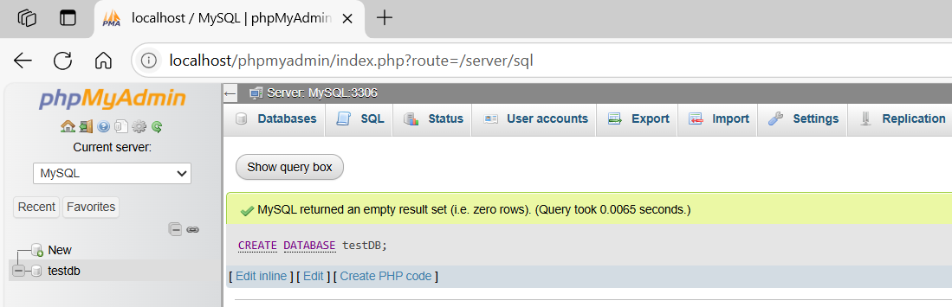
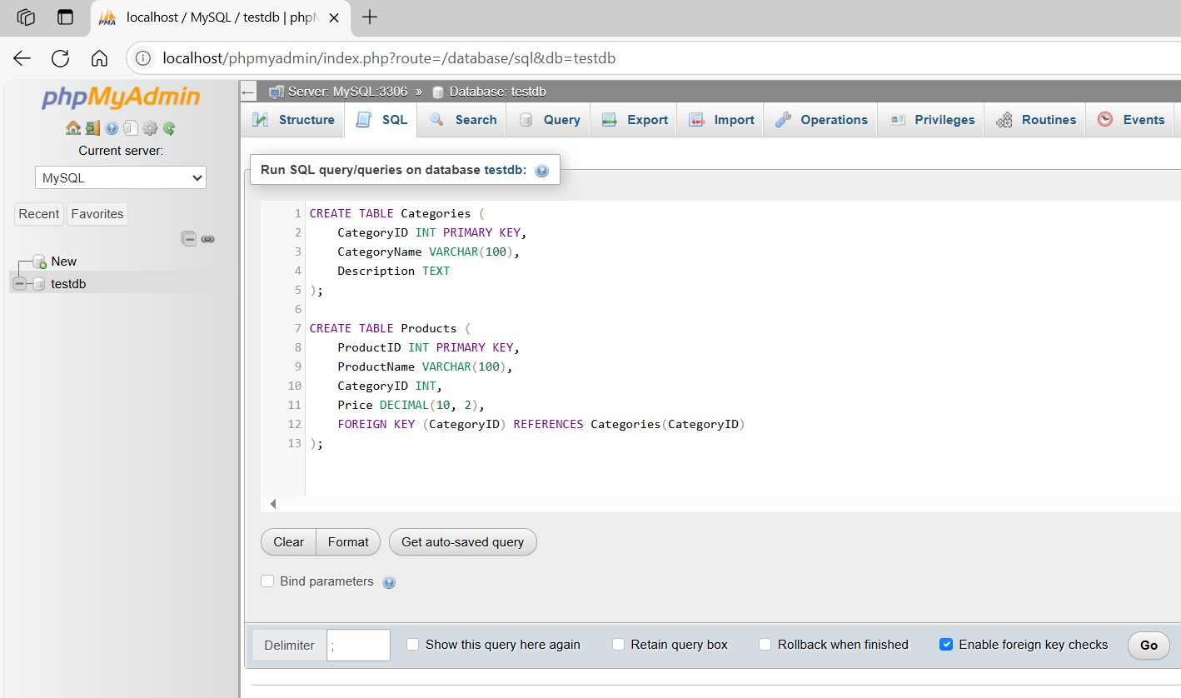
CREATE TABLE Categories (
CategoryID INT PRIMARY KEY,
CategoryName VARCHAR(100),
Description TEXT
);

CREATE TABLE Products (
ProductID INT PRIMARY KEY,
ProductName VARCHAR(100),
CategoryID INT,
Price DECIMAL(10, 2),
FOREIGN KEY (CategoryID) REFERENCES Categories(CategoryID)
);
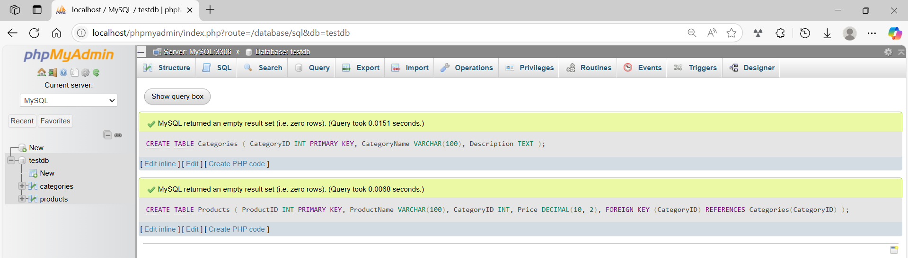
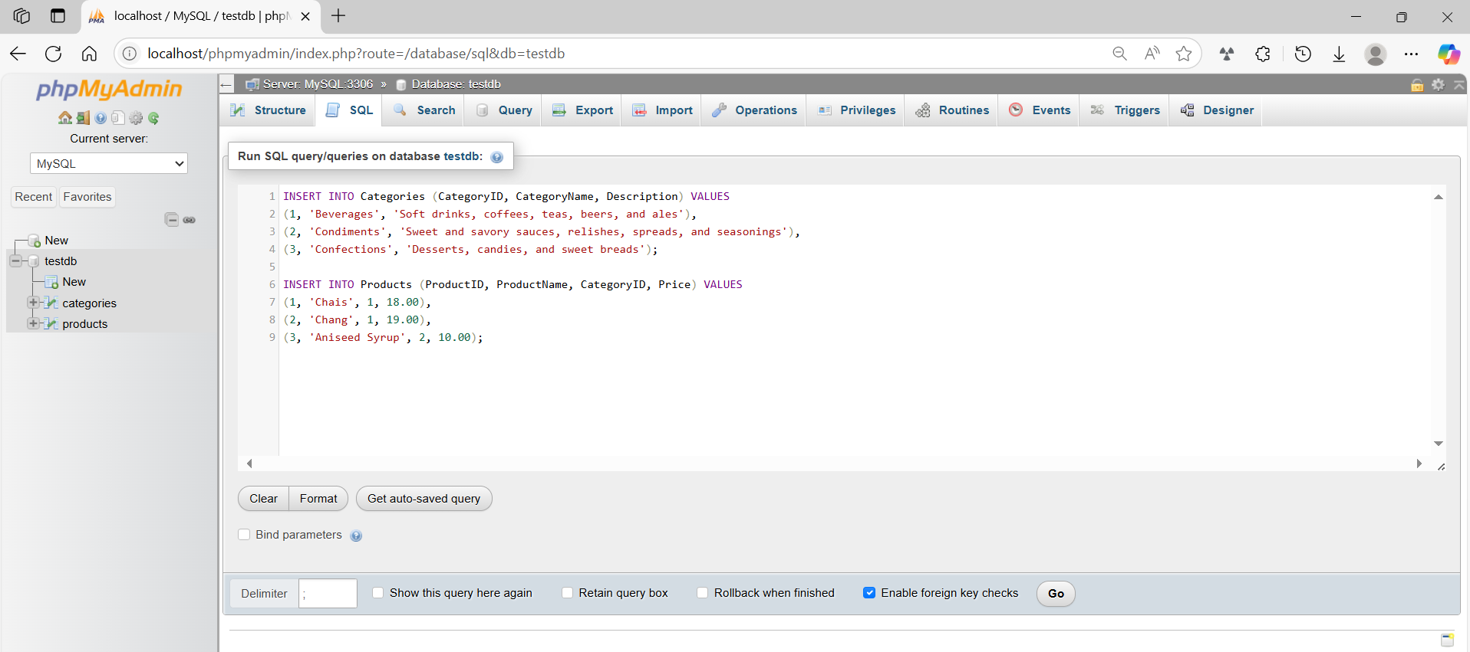
INSERT INTO Categories (CategoryID, CategoryName, Description) VALUES
(1, 'Beverages', 'Soft drinks, coffees, teas, beers, and ales'),
(2, 'Condiments', 'Sweet and savory sauces, relishes, spreads, and seasonings'),
(3, 'Confections', 'Desserts, candies, and sweet breads');

INSERT INTO Products (ProductID, ProductName, CategoryID, Price) VALUES
(1, 'Chais', 1, 18.00),
(2, 'Chang', 1, 19.00),
(3, 'Aniseed Syrup', 2, 10.00);
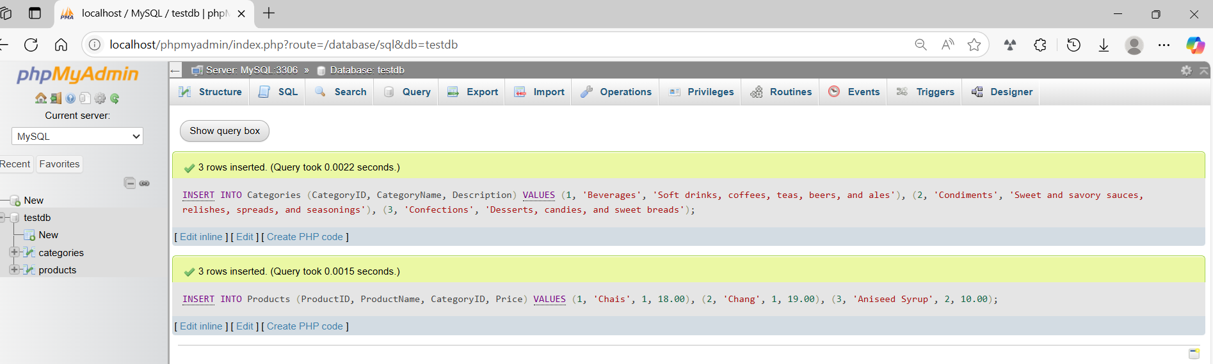
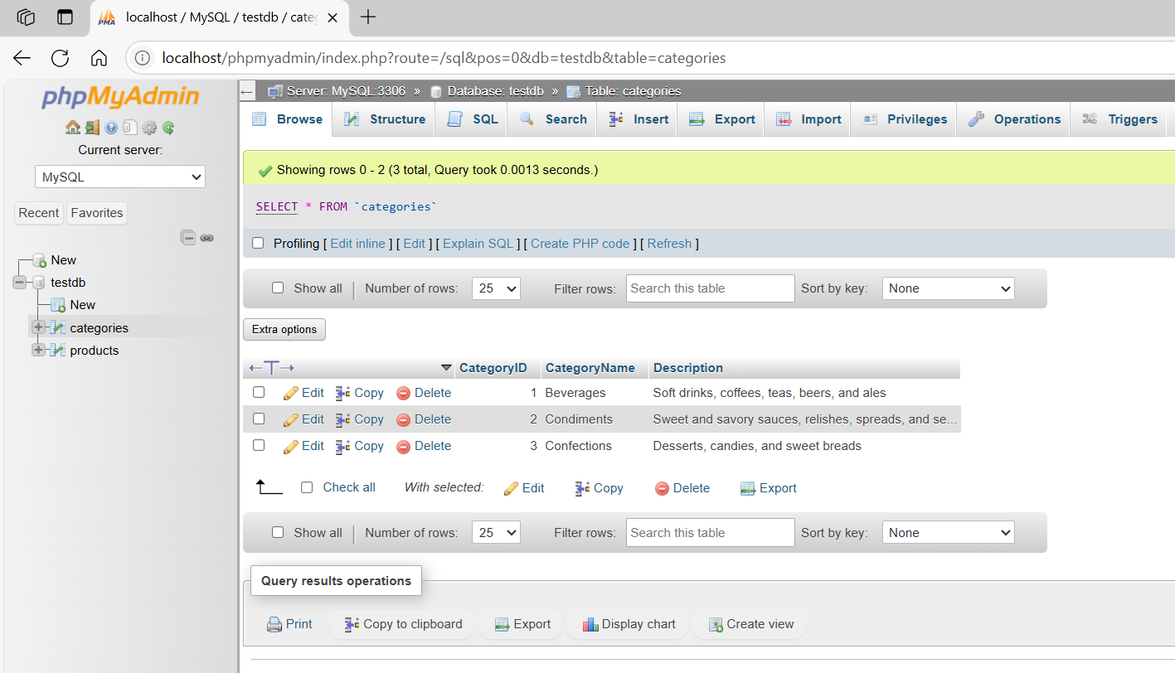
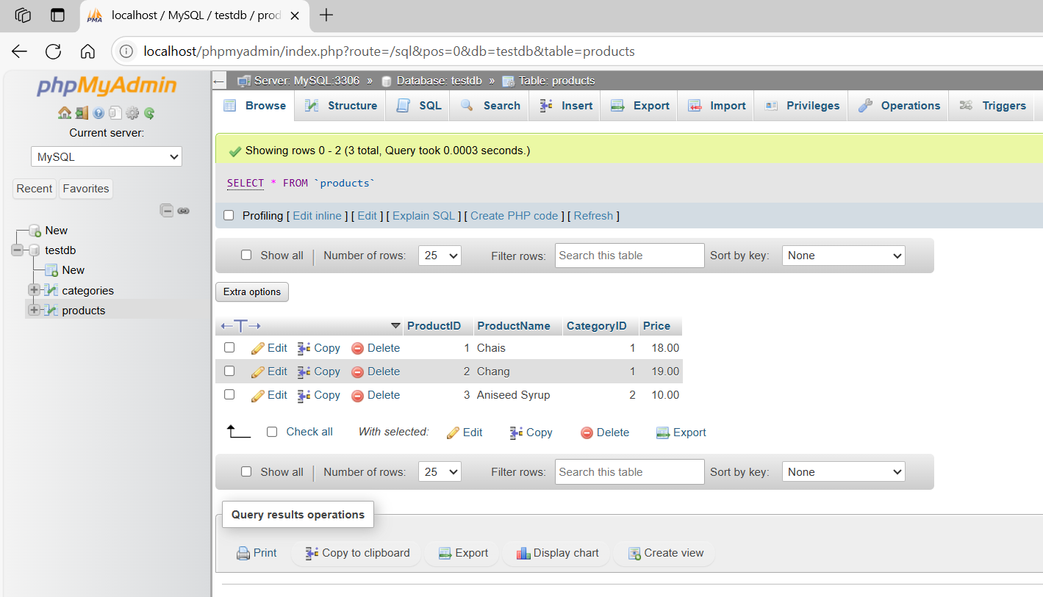

basic command
# Source: ScreenShot Source: Provided by: [Persons Table -> ID Column: 1, Name_En Column: Motasem Essam] -> Tool: [Automation Table -> ID Column: 16, Name_En Column: Screen Capture] -> From [Operating System: Wampserver64 -> phpmyadmin] on [6/11/2026]
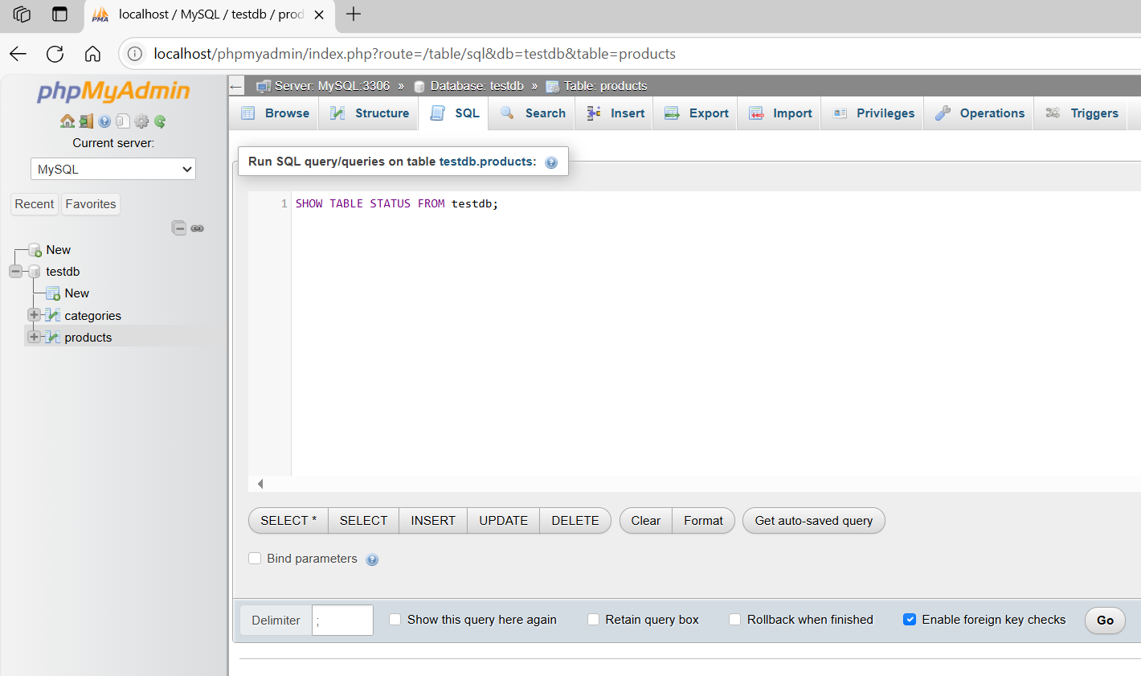
SHOW TABLE STATUS FROM testdb;
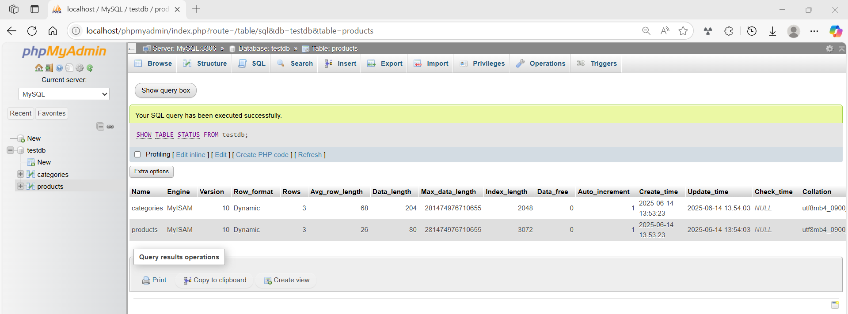
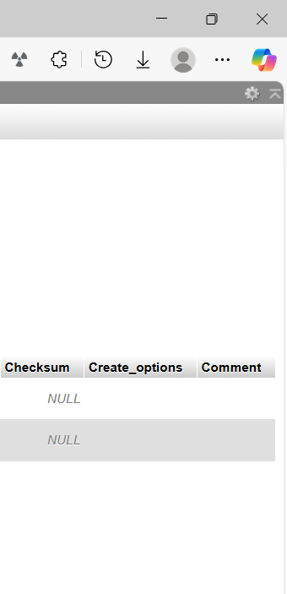

basic command
# Source: ScreenShot Source: Provided by: [Persons Table -> ID Column: 1, Name_En Column: Motasem Essam] -> Tool: [Automation Table -> ID Column: 16, Name_En Column: Screen Capture] -> From [Operating System: Wampserver64 -> phpmyadmin] on [6/11/2026]
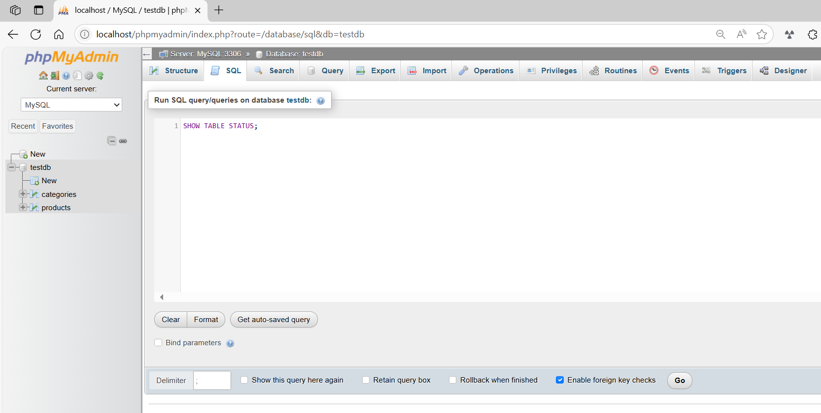
SHOW TABLE STATUS;
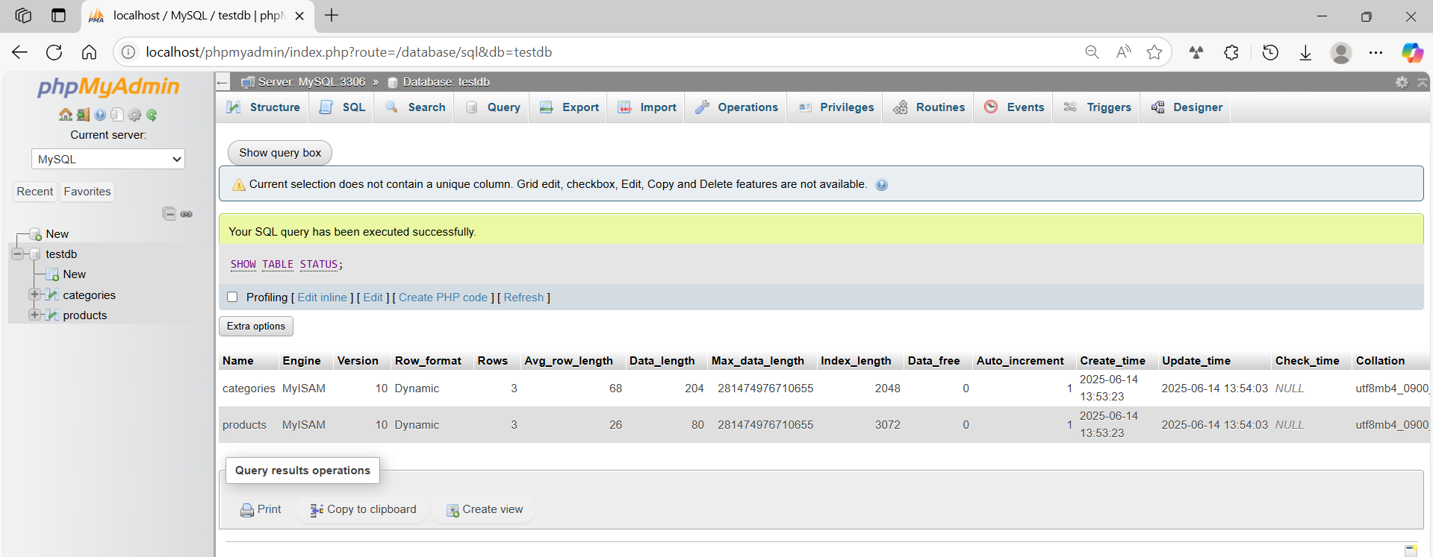
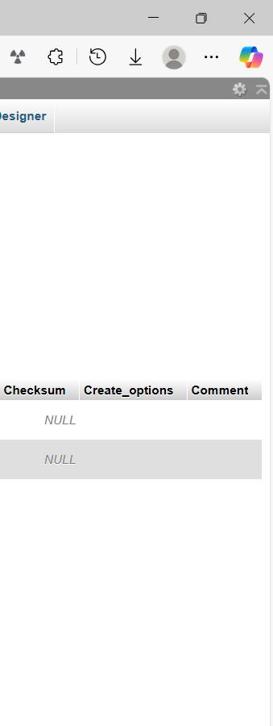

basic command
# Source: ScreenShot Source: Provided by: [Persons Table -> ID Column: 1, Name_En Column: Motasem Essam] -> Tool: [Automation Table -> ID Column: 16, Name_En Column: Screen Capture] -> From [Operating System: Wampserver64 -> phpmyadmin] on [6/11/2026]
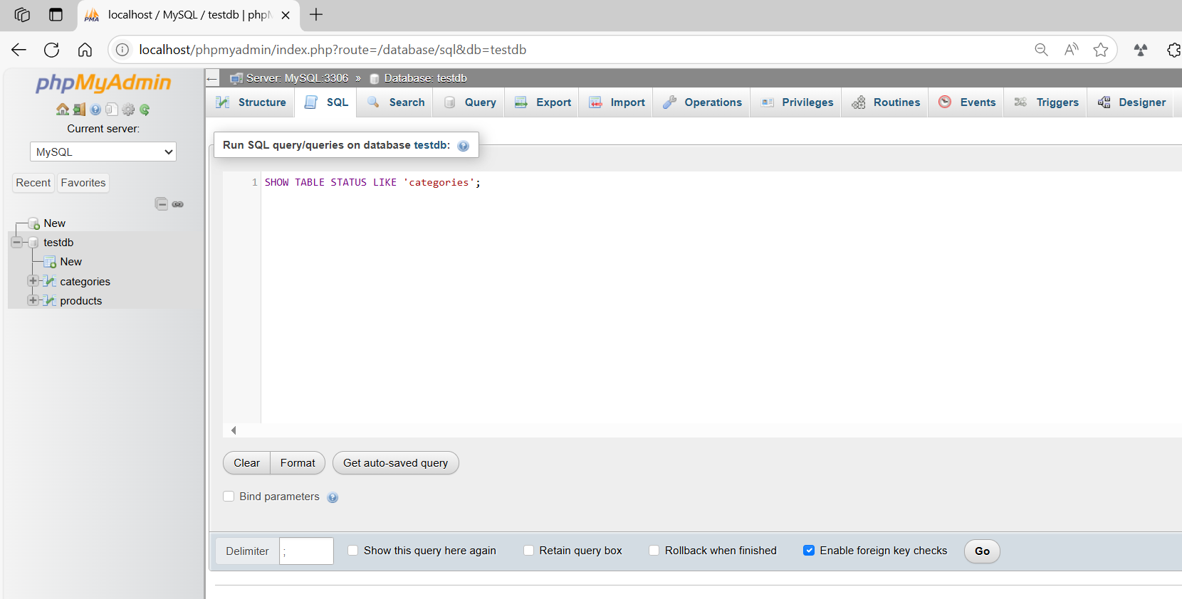
SHOW TABLE STATUS LIKE 'categories';
